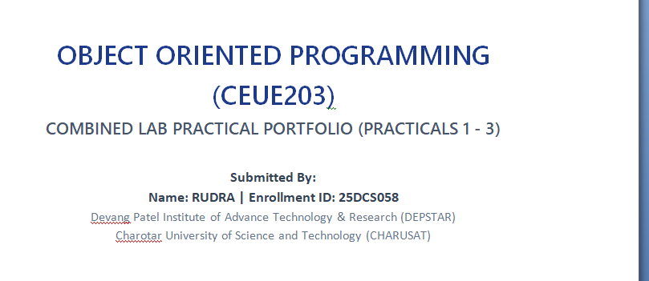 | 

WEB DEVELOPMENT FRAMEWORKS
(ITUE203)
COMBINED LAB PRACTICAL PORTFOLIO (PRACTICALS 1 - 2)
- SITEMAP, WIREFRAMES & BROWSER OUTPUTS -
Submitted By:
Name: RUDRA | Enrollment ID: 25DCS058
Devang Patel Institute of Advance Technology & Research (DEPSTAR)
Charotar University of Science and Technology (CHARUSAT)

1. Visual Site Sitemap Diagram
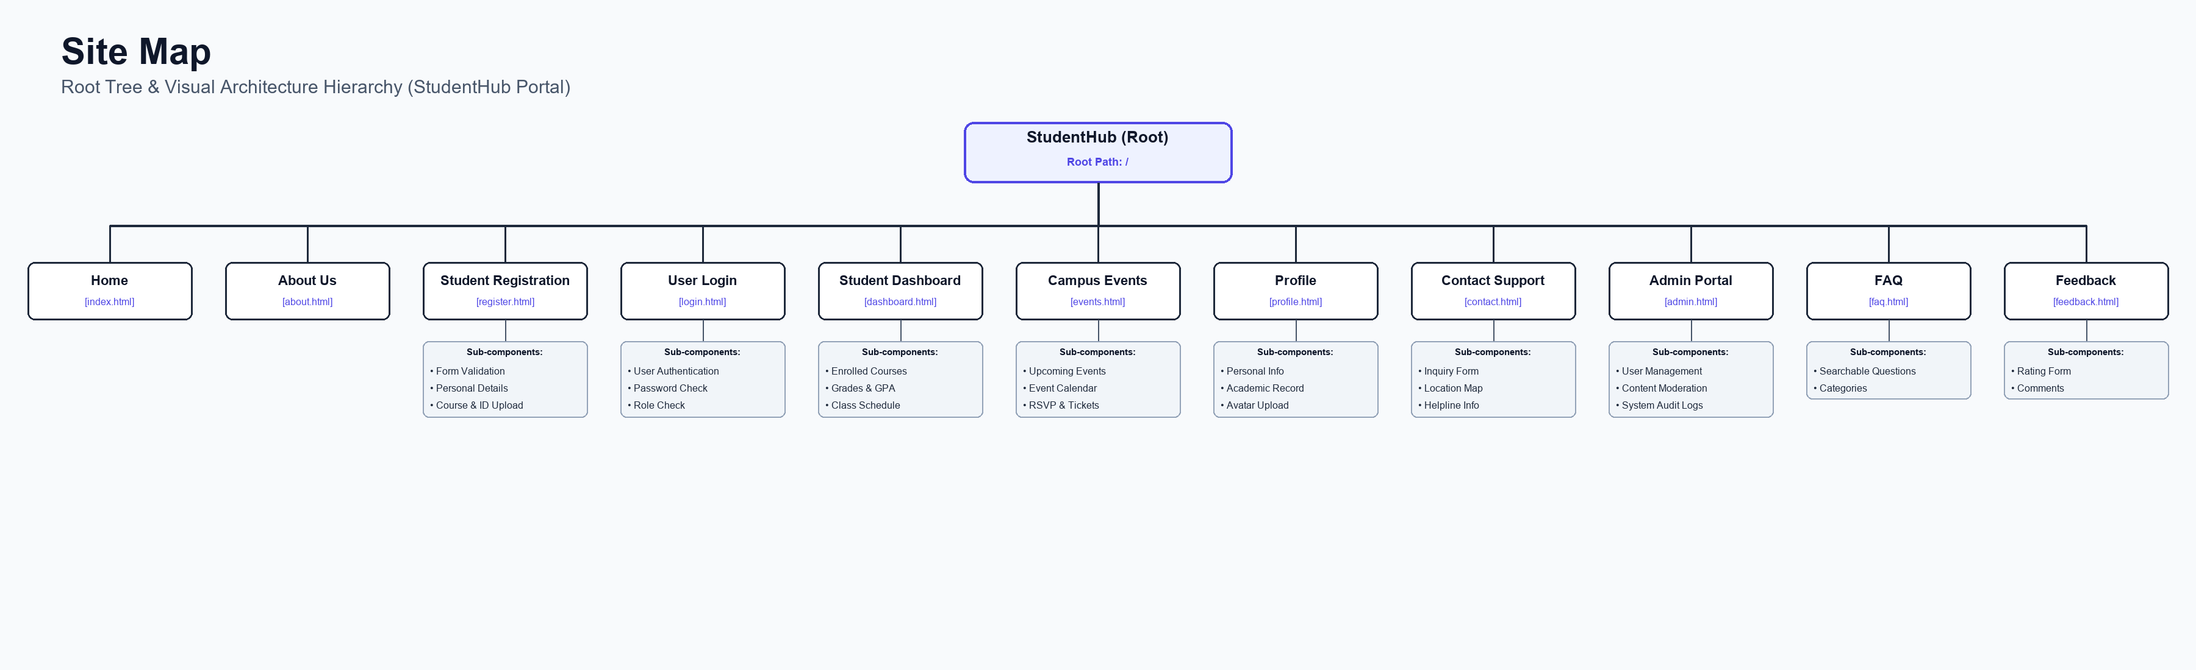
Figure: Site Sitemap Hierarchy Diagram

2. Sitemap, Wireframes & Browser Output Screenshots

Page: Home Page (index.html)

Low-Fidelity Wireframe Blueprint
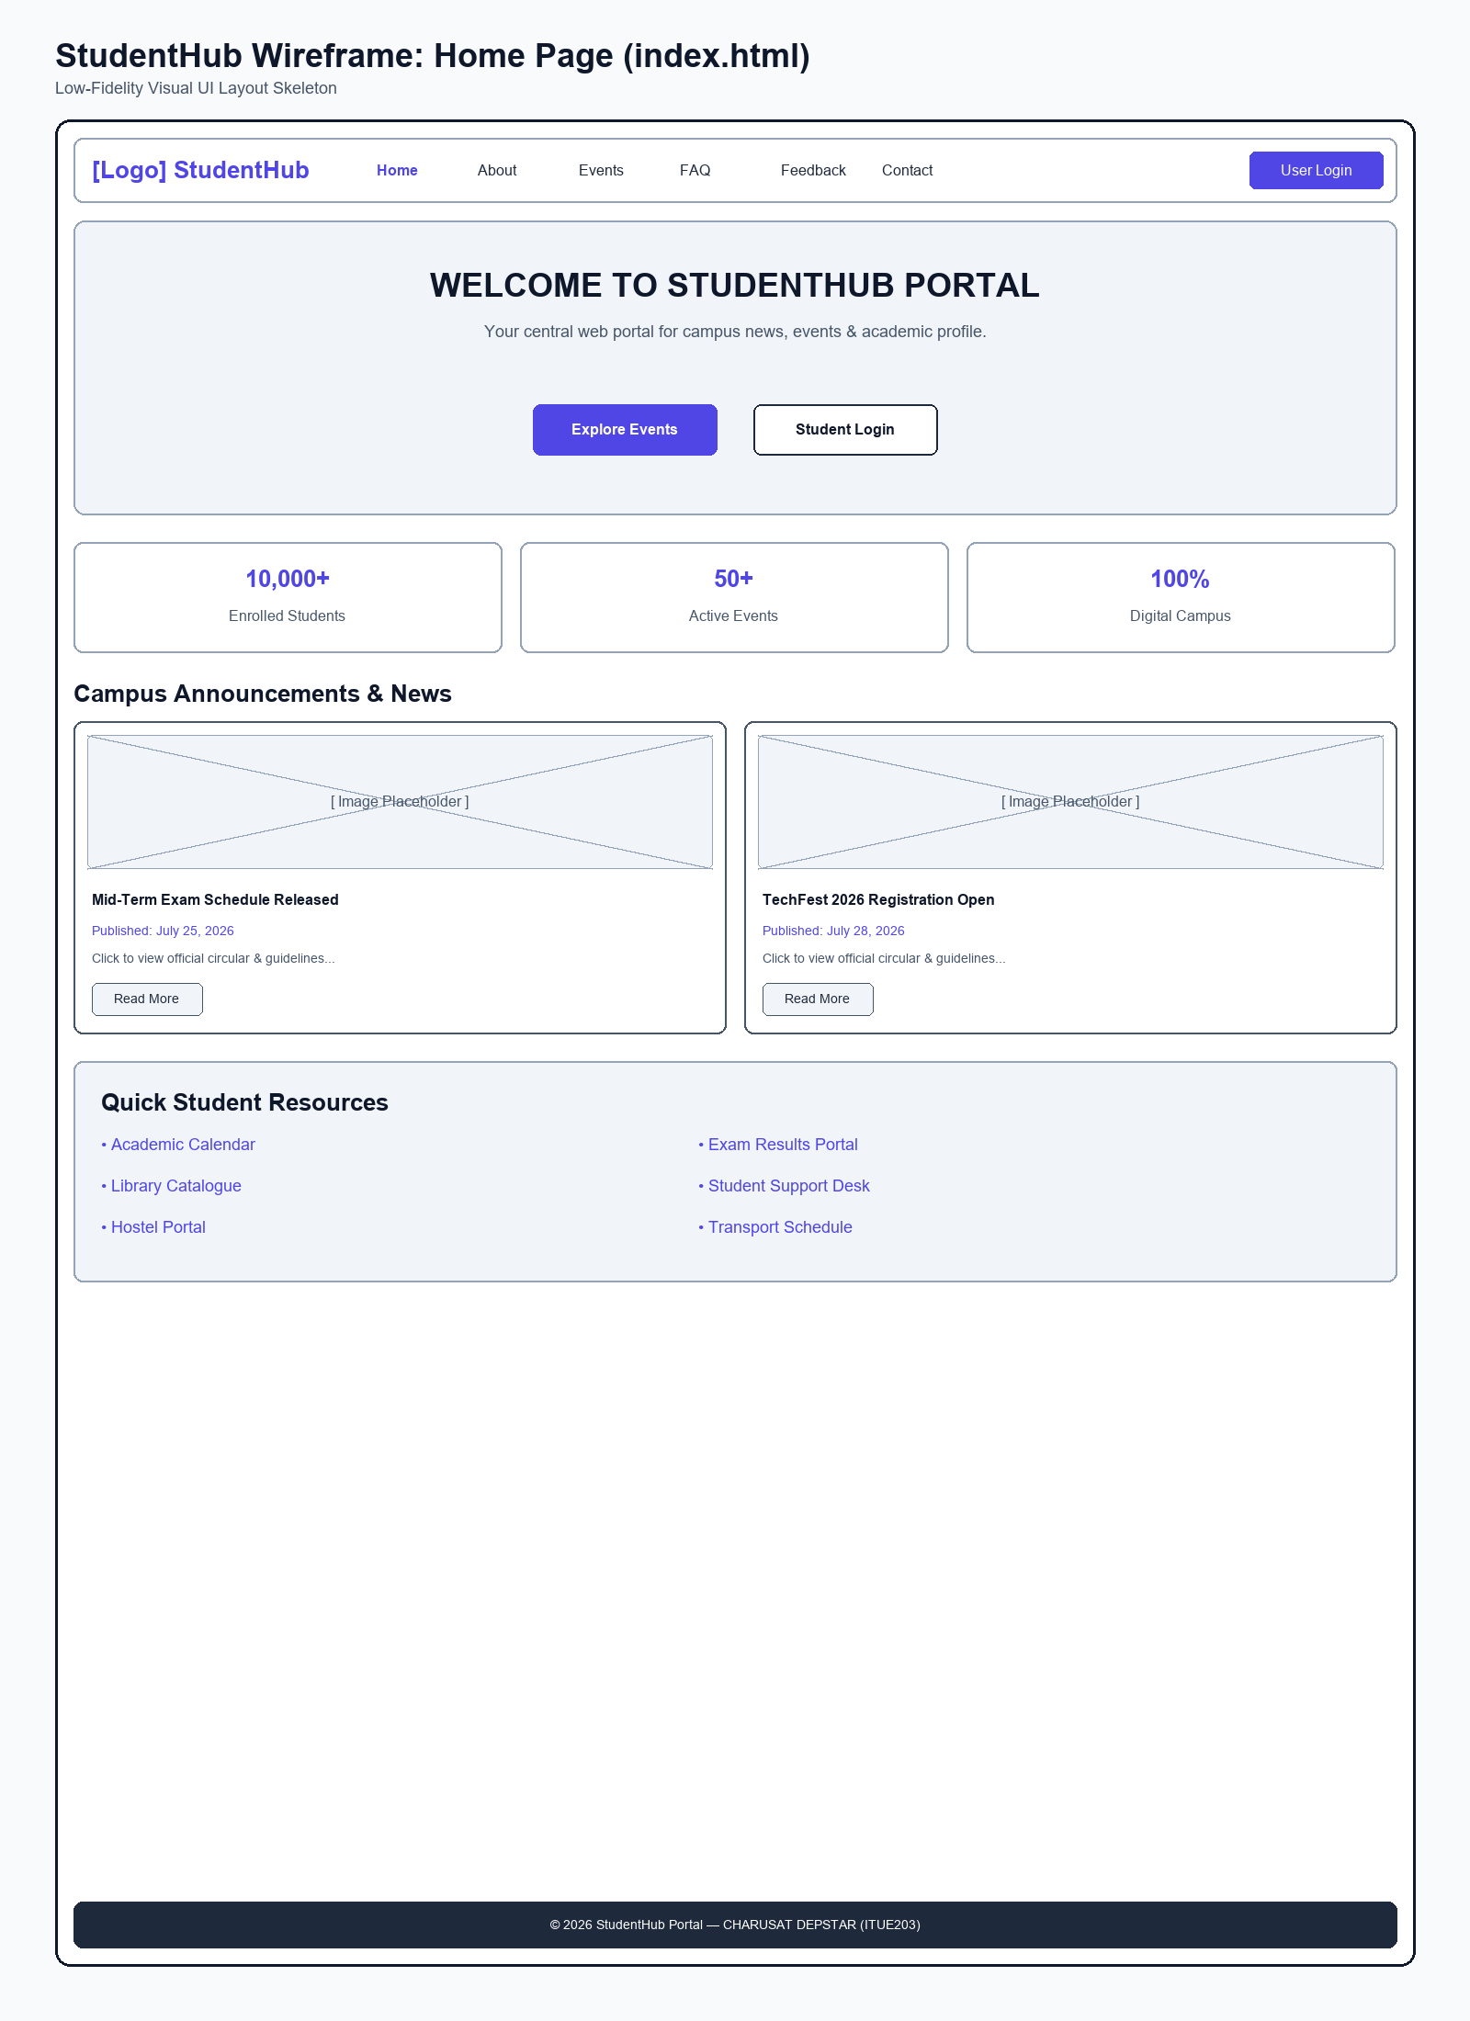
Figure: Wireframe blueprint layout for Home Page

Browser Webpage Output Screenshot
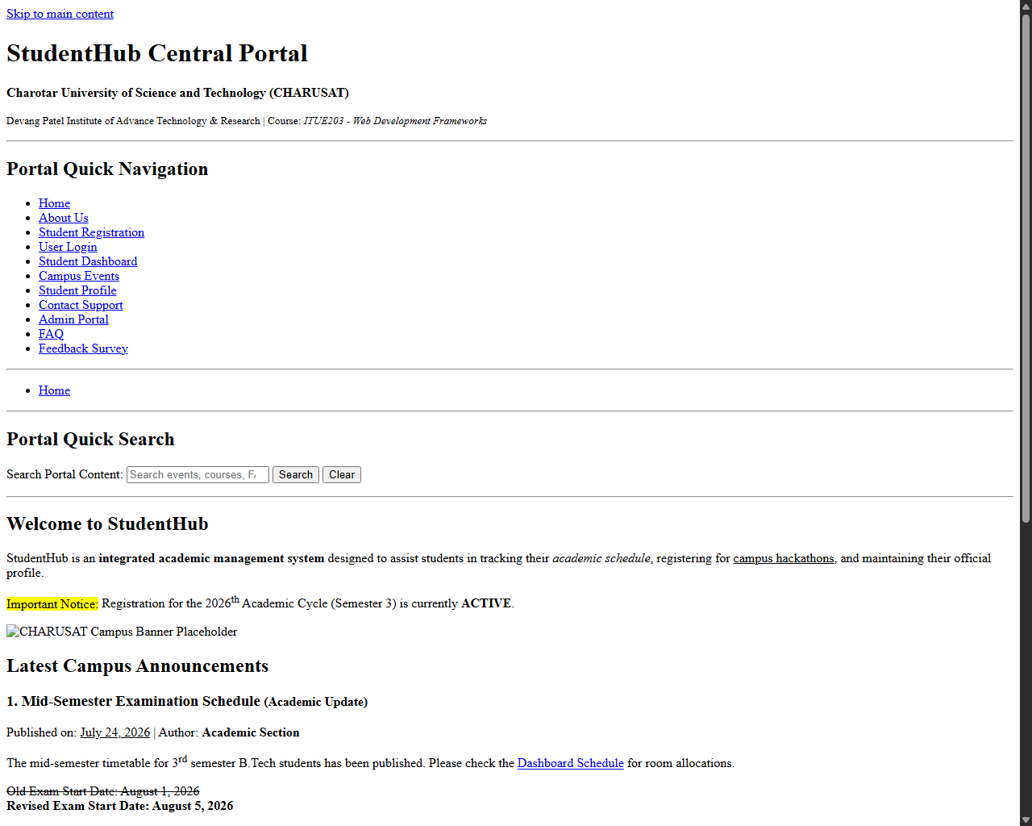
Figure: Browser output screenshot for Home Page

Page: About Us Page (about.html)

Low-Fidelity Wireframe Blueprint
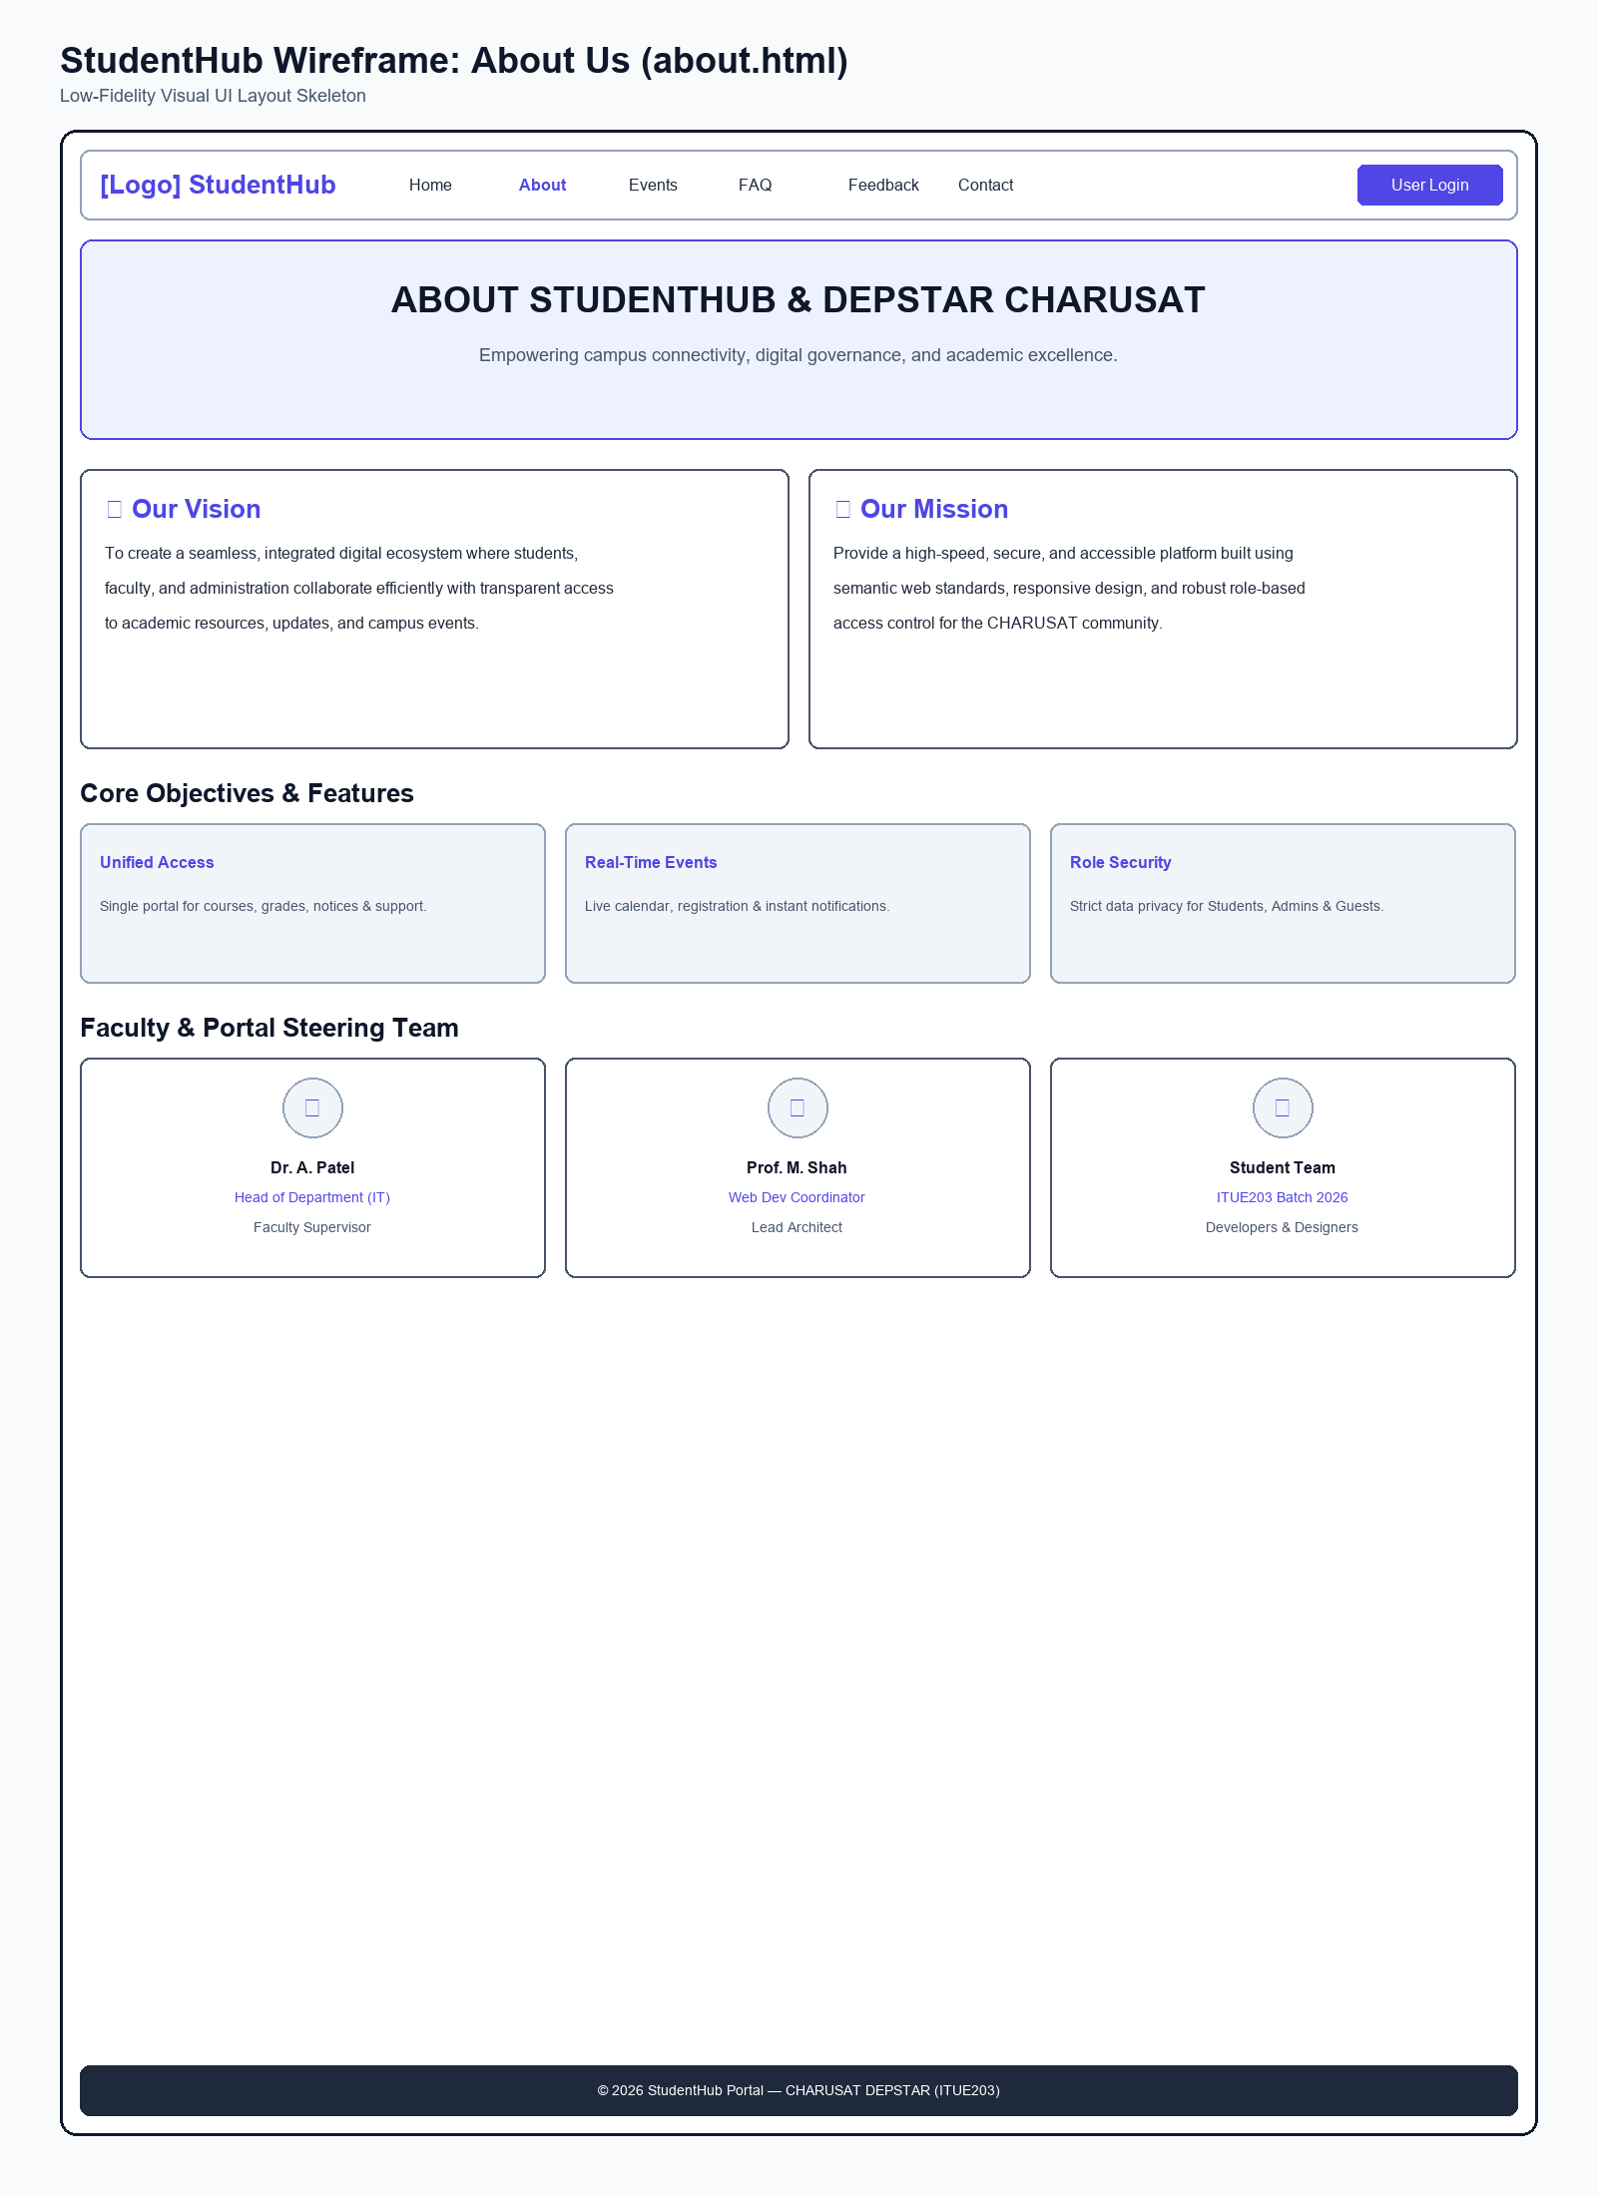
Figure: Wireframe blueprint layout for About Us Page

Browser Webpage Output Screenshot
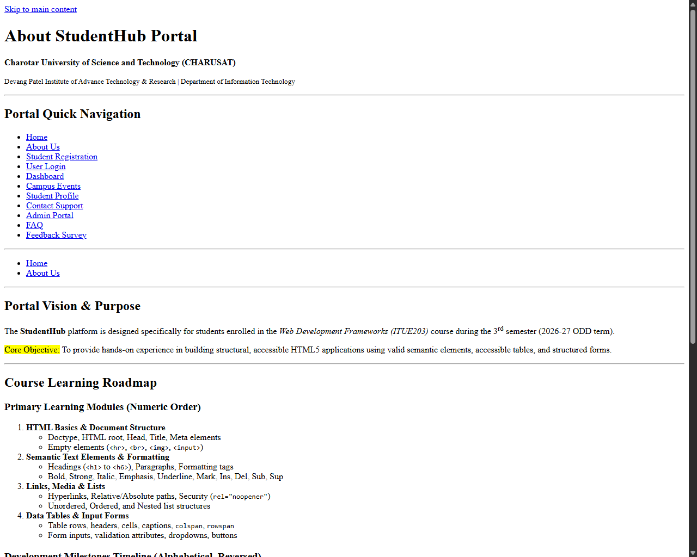
Figure: Browser output screenshot for About Us Page

Page: Student Registration Page (register.html)

Low-Fidelity Wireframe Blueprint
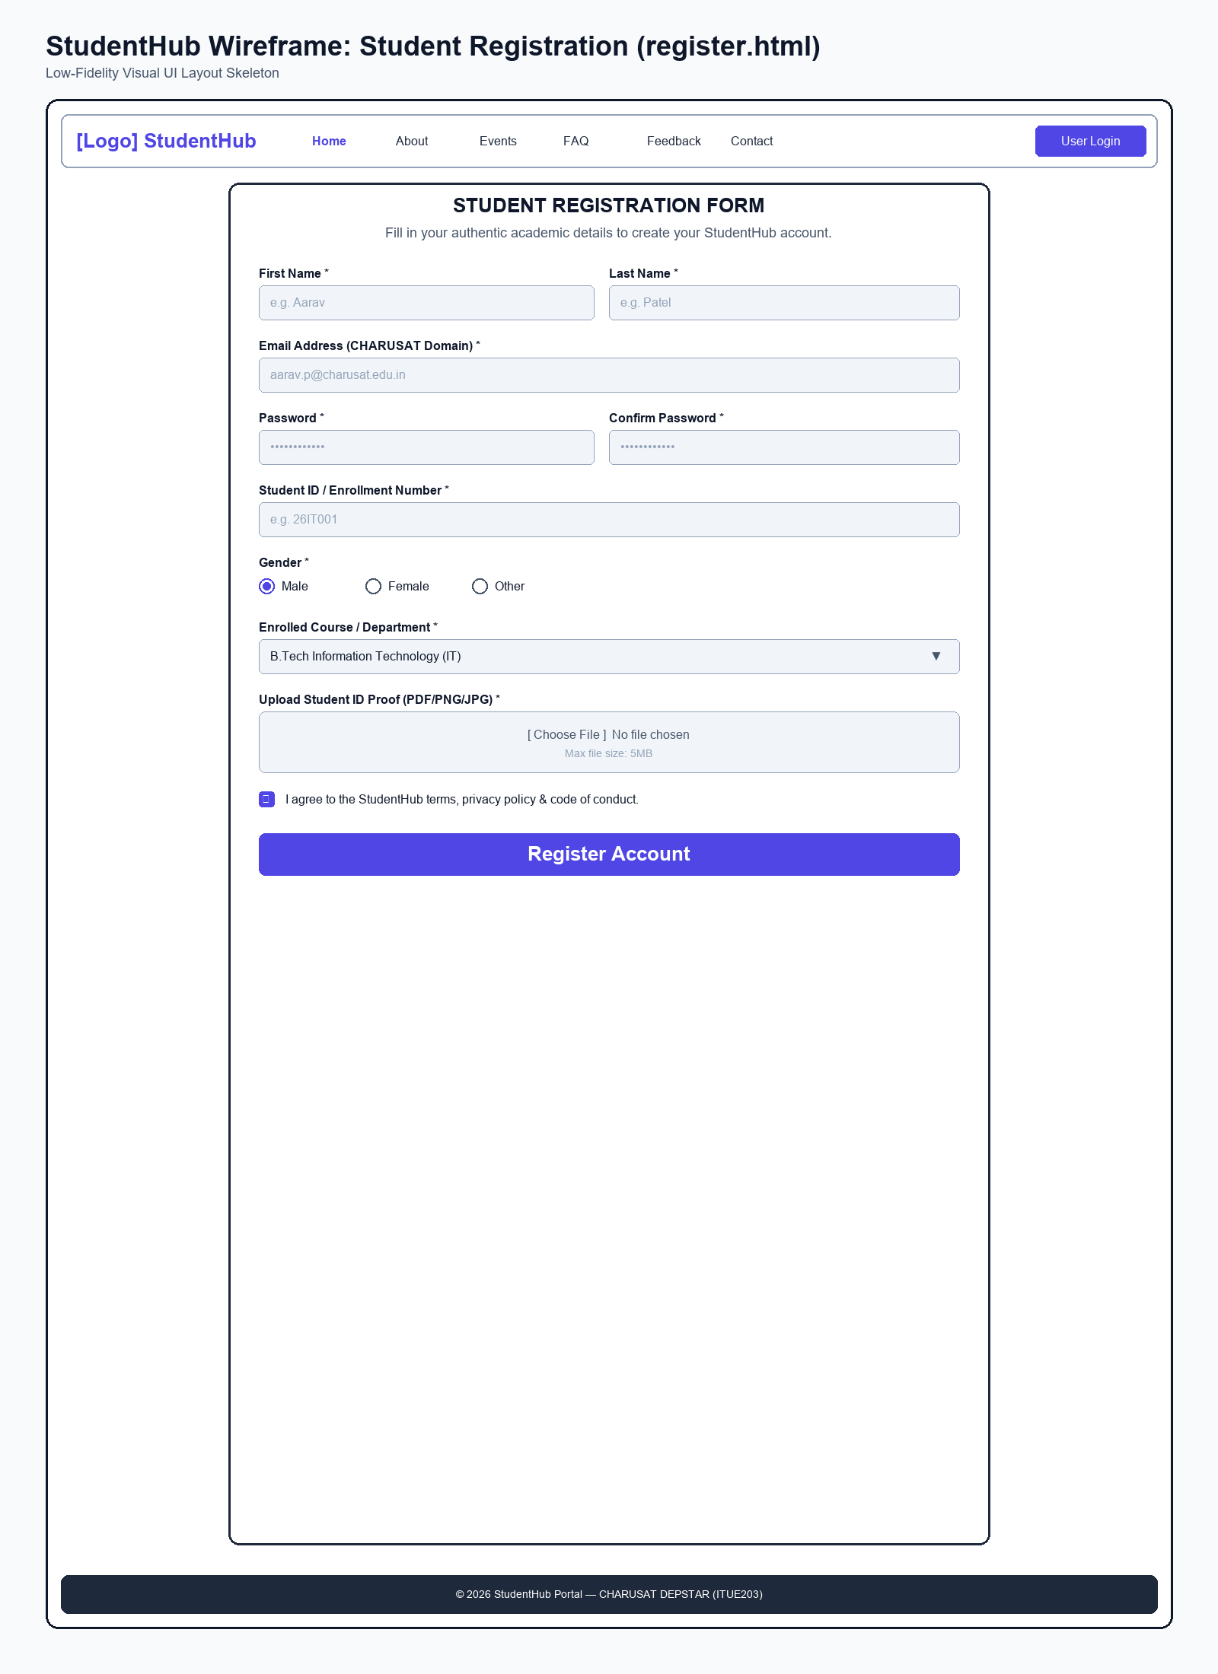
Figure: Wireframe blueprint layout for Student Registration Page

Browser Webpage Output Screenshot
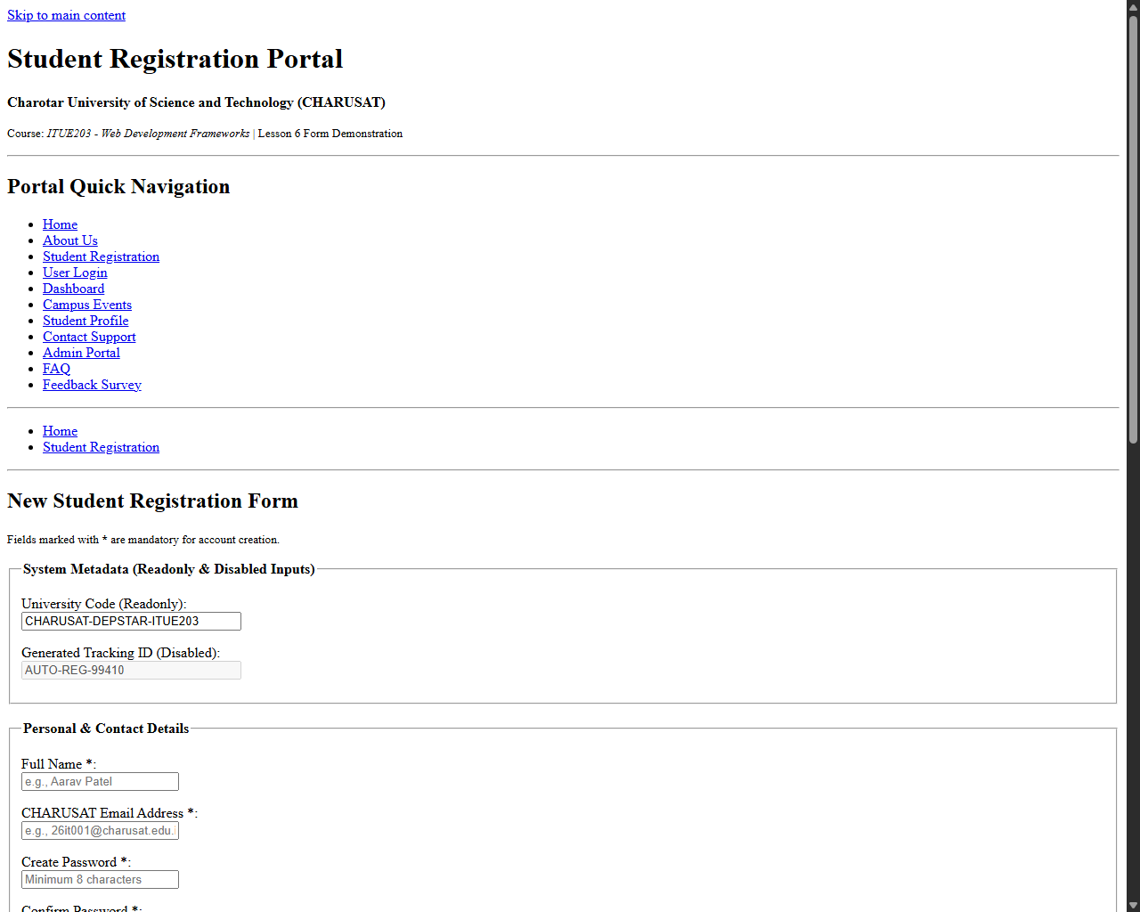
Figure: Browser output screenshot for Student Registration Page

Page: User Login Page (login.html)

Low-Fidelity Wireframe Blueprint
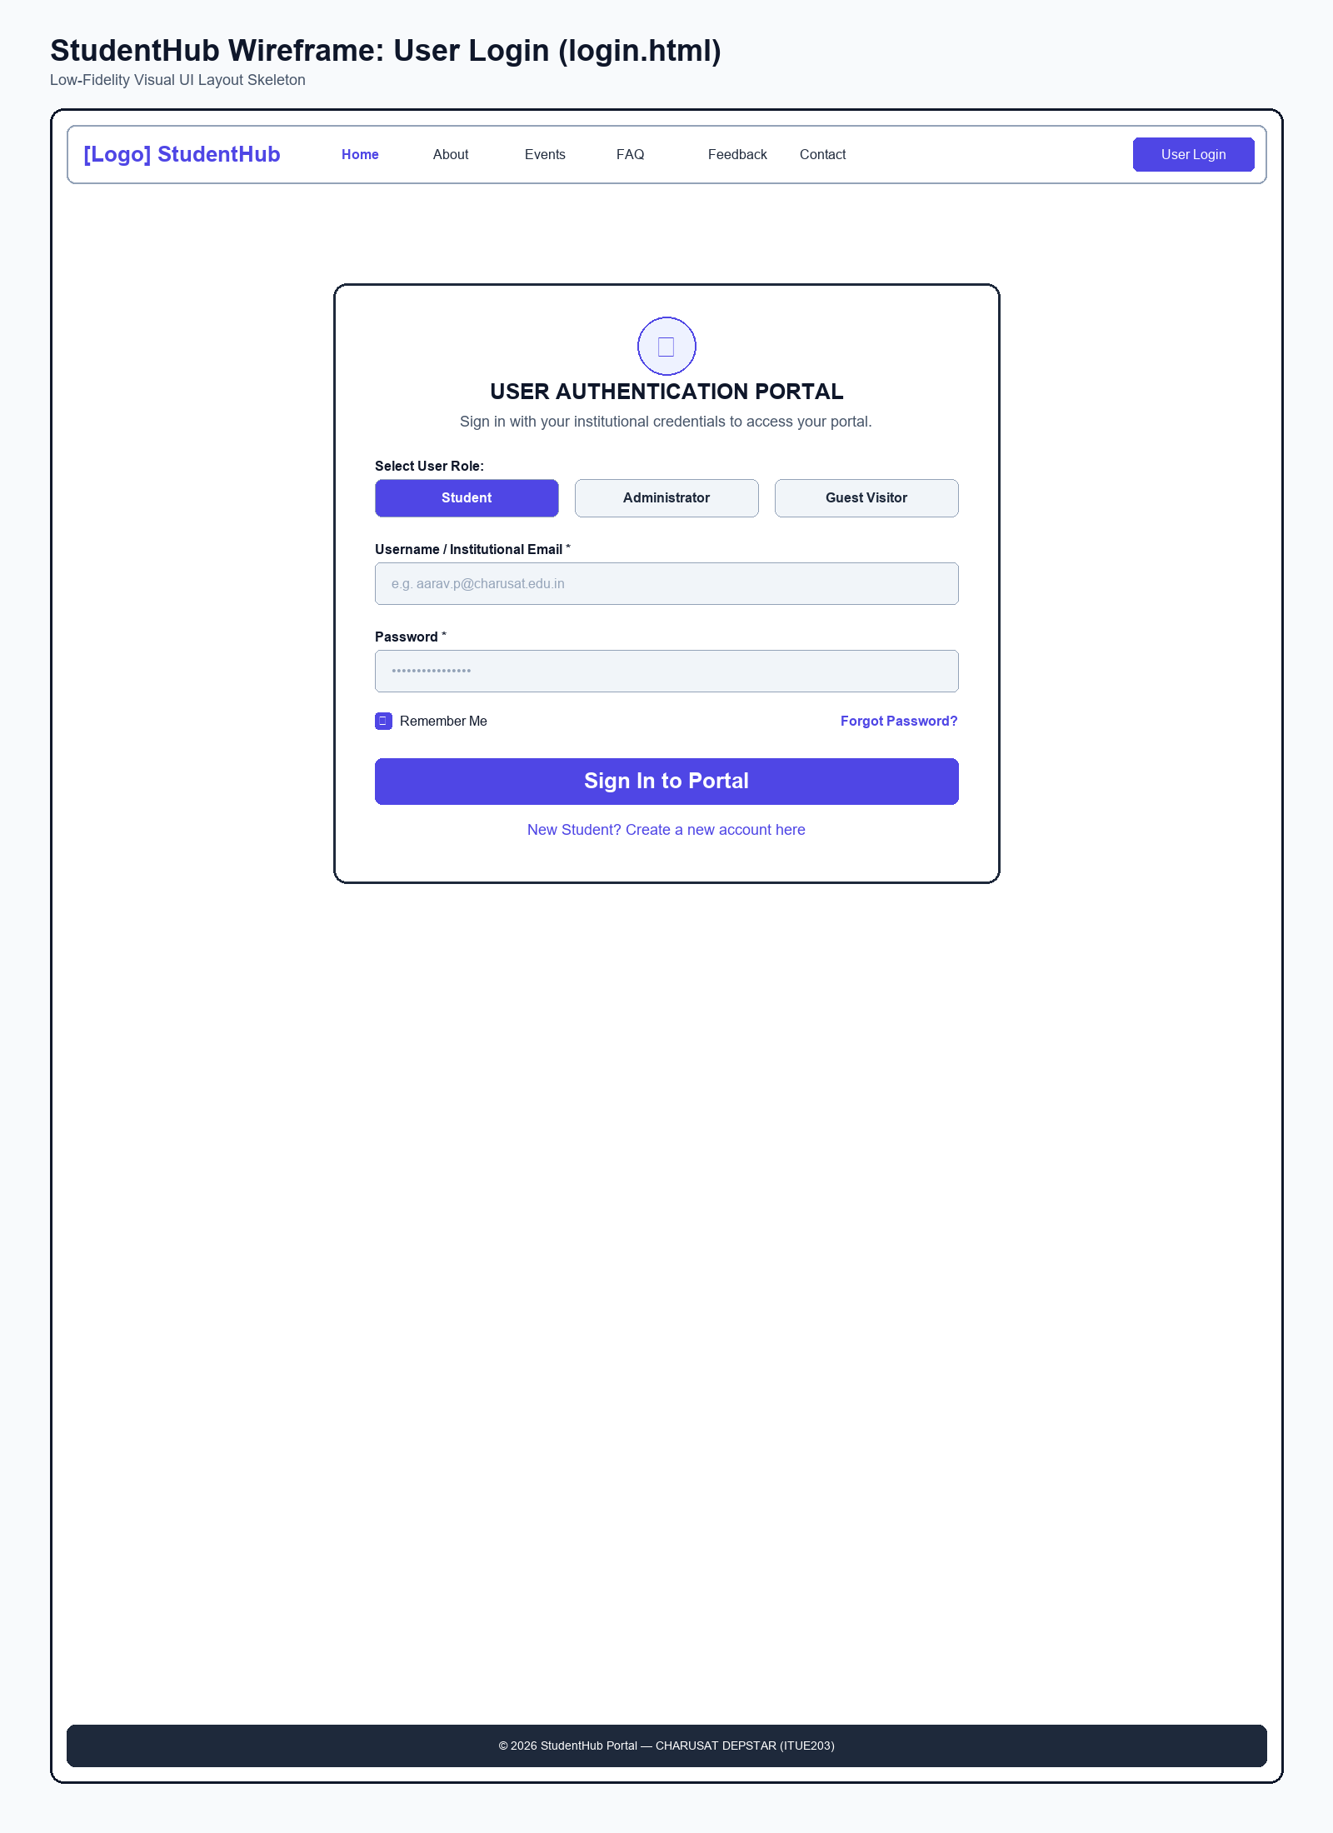
Figure: Wireframe blueprint layout for User Login Page

Browser Webpage Output Screenshot
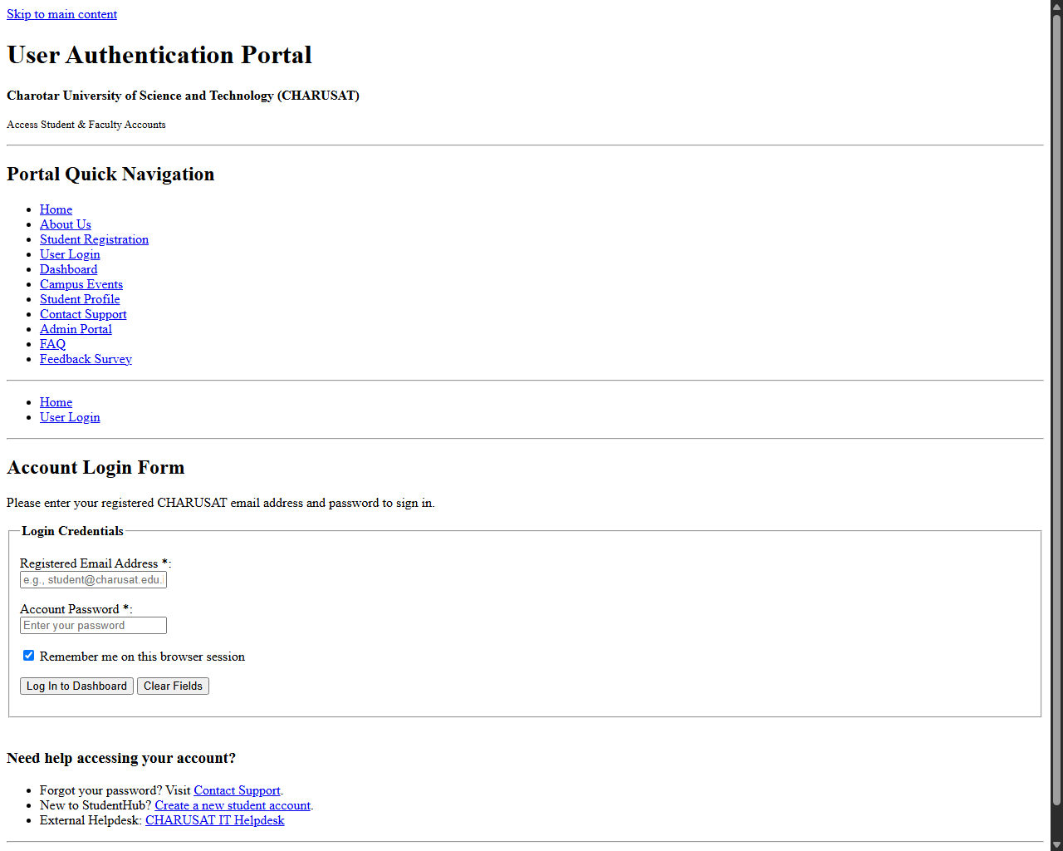
Figure: Browser output screenshot for User Login Page

Page: Student Dashboard Page (dashboard.html)

Low-Fidelity Wireframe Blueprint
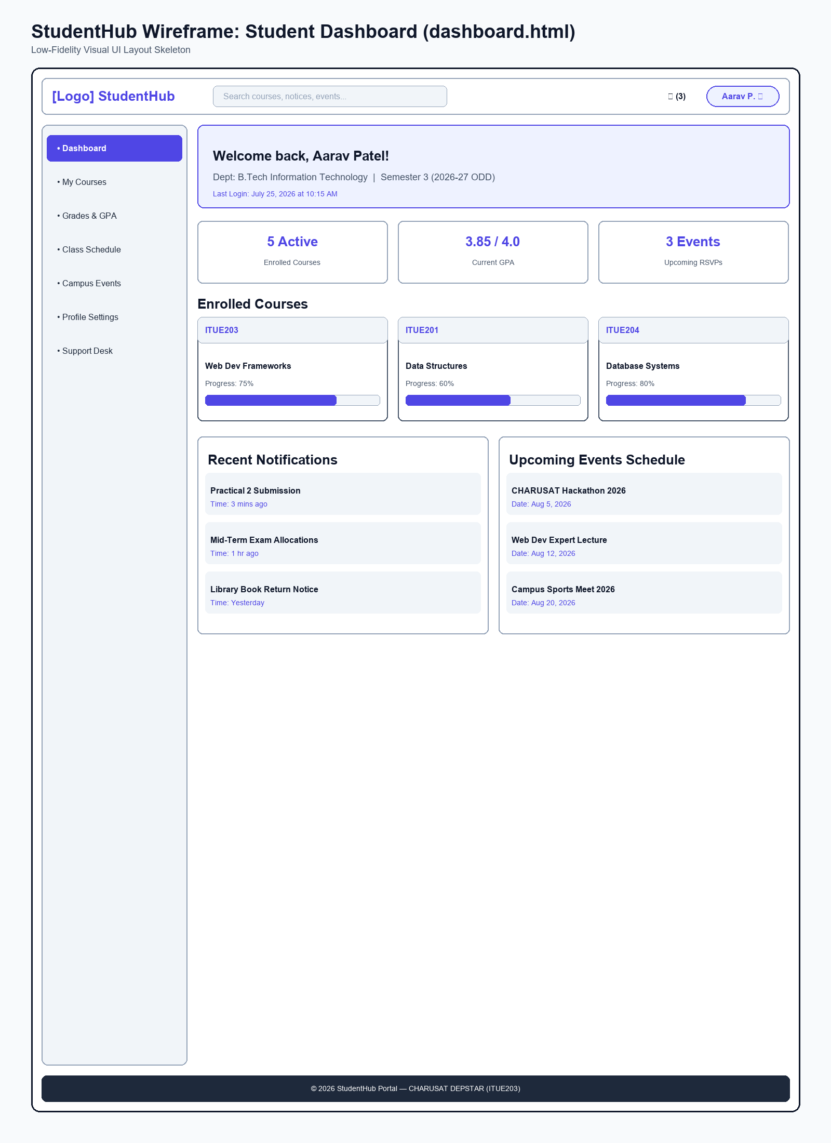
Figure: Wireframe blueprint layout for Student Dashboard Page

Browser Webpage Output Screenshot
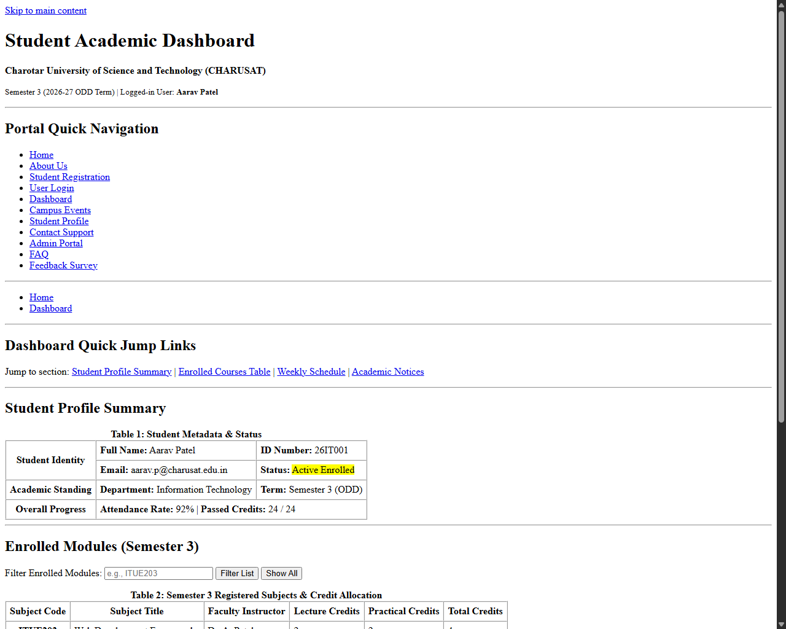
Figure: Browser output screenshot for Student Dashboard Page

Page: Campus Events Page (events.html)

Low-Fidelity Wireframe Blueprint
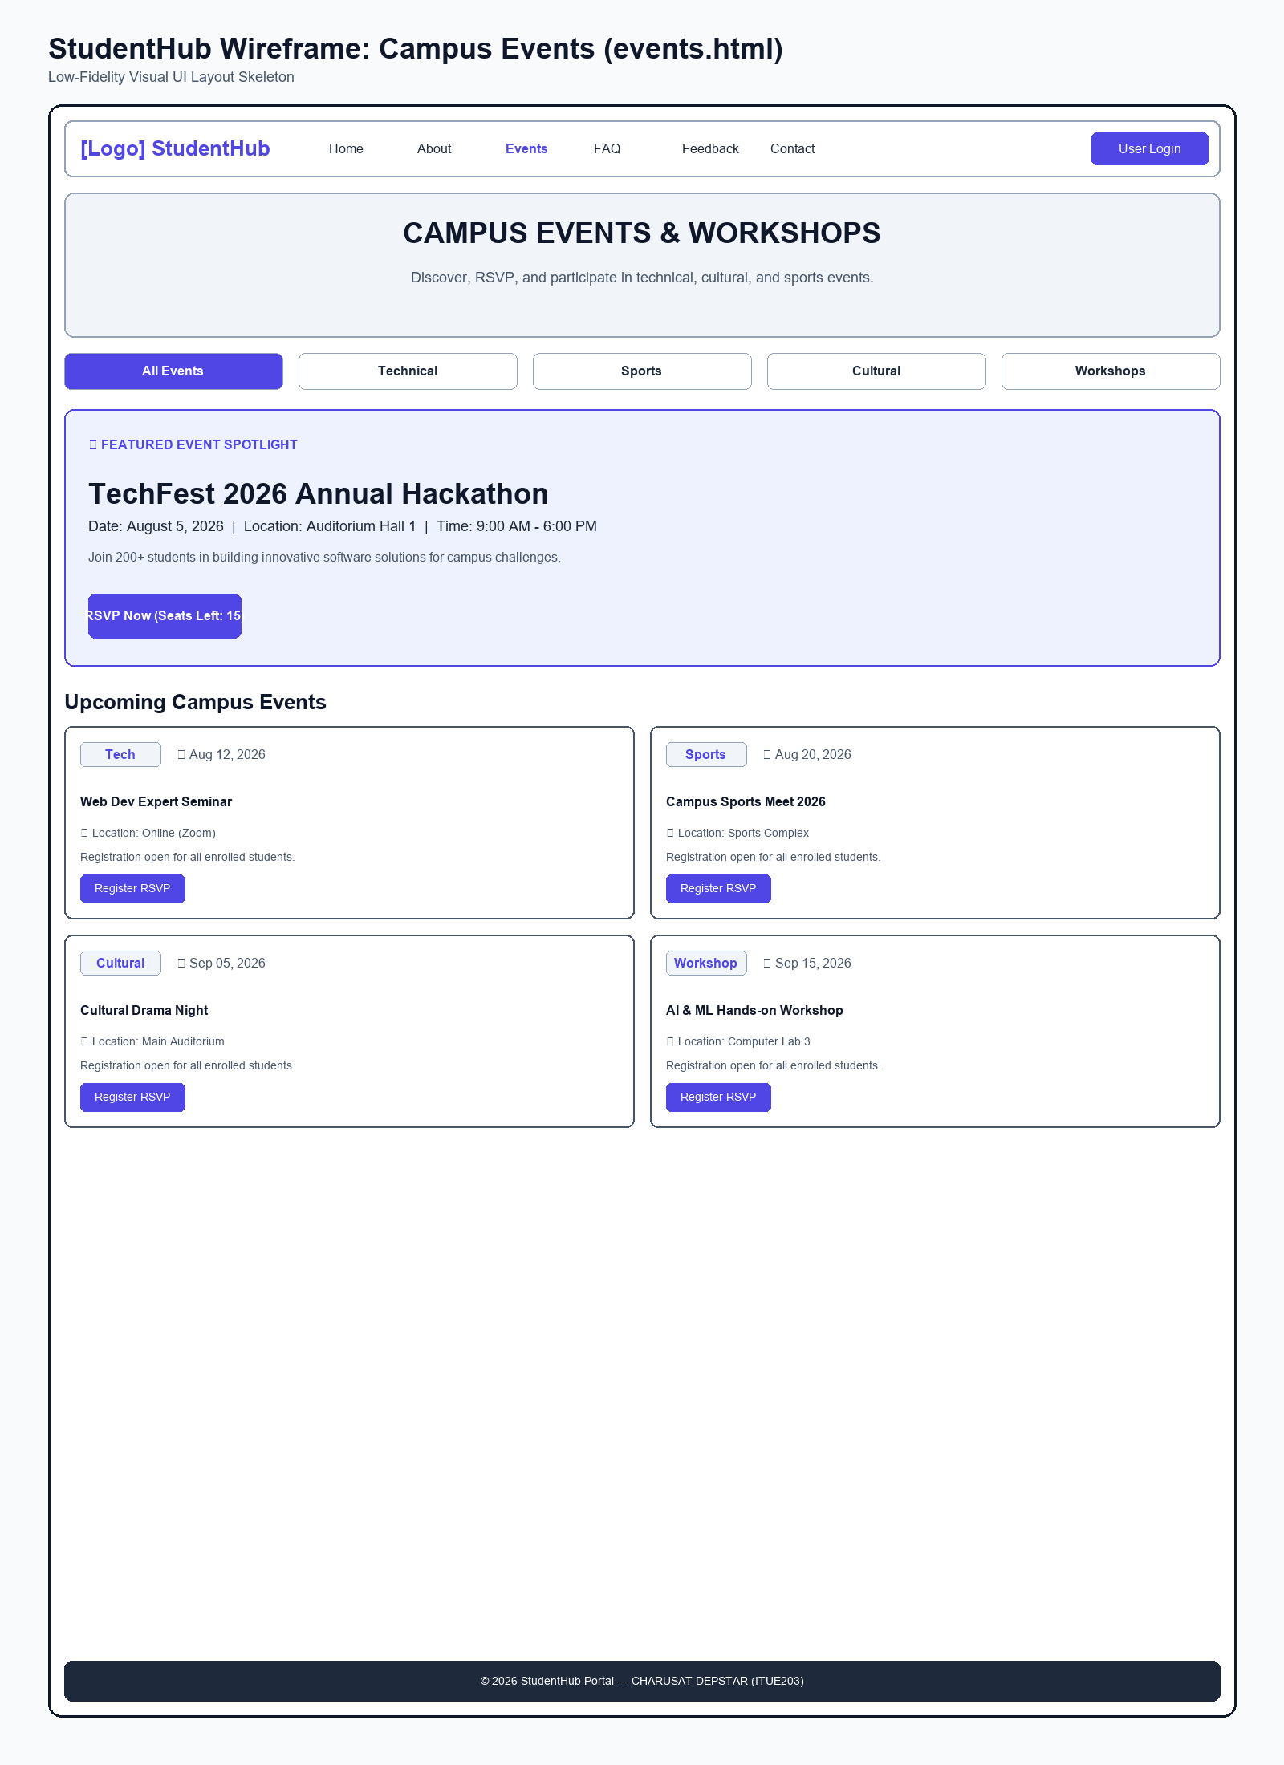
Figure: Wireframe blueprint layout for Campus Events Page

Browser Webpage Output Screenshot
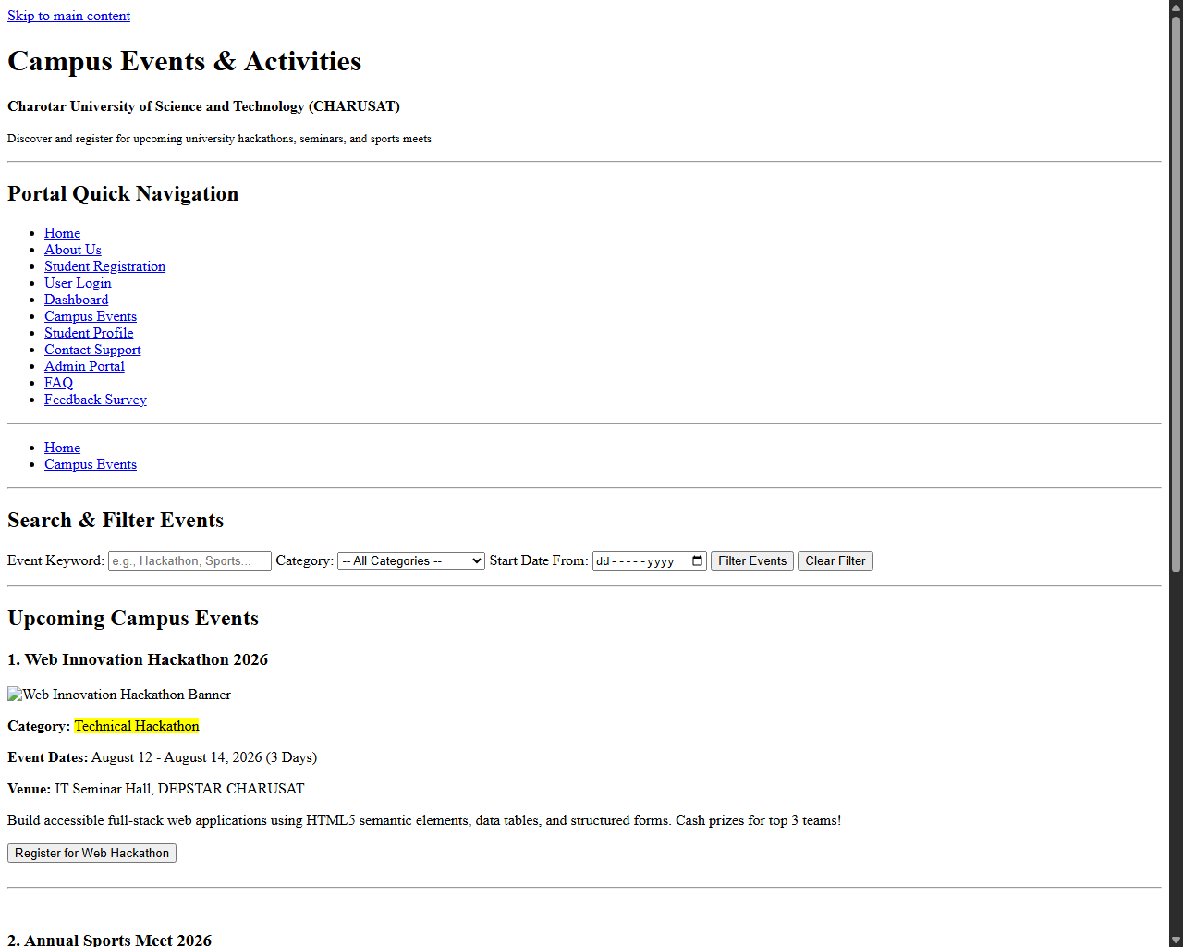
Figure: Browser output screenshot for Campus Events Page

Page: Student Profile Page (profile.html)

Low-Fidelity Wireframe Blueprint
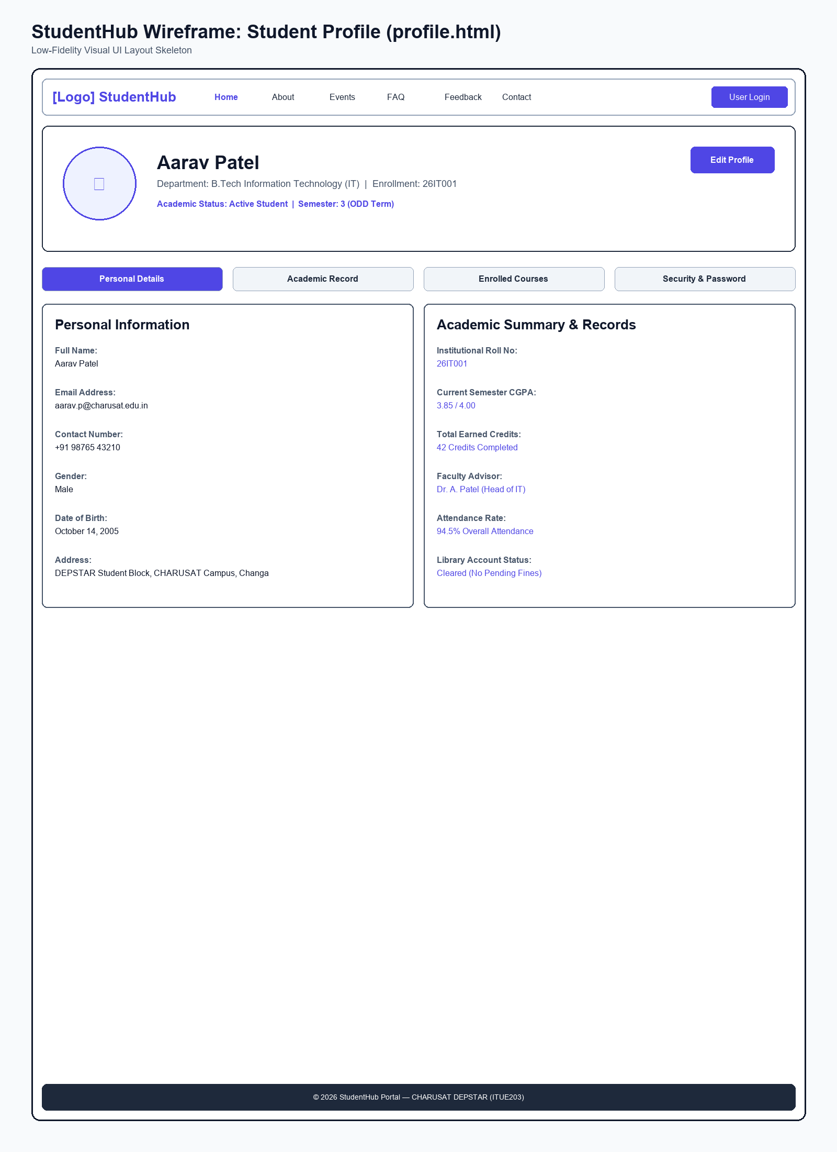
Figure: Wireframe blueprint layout for Student Profile Page

Browser Webpage Output Screenshot
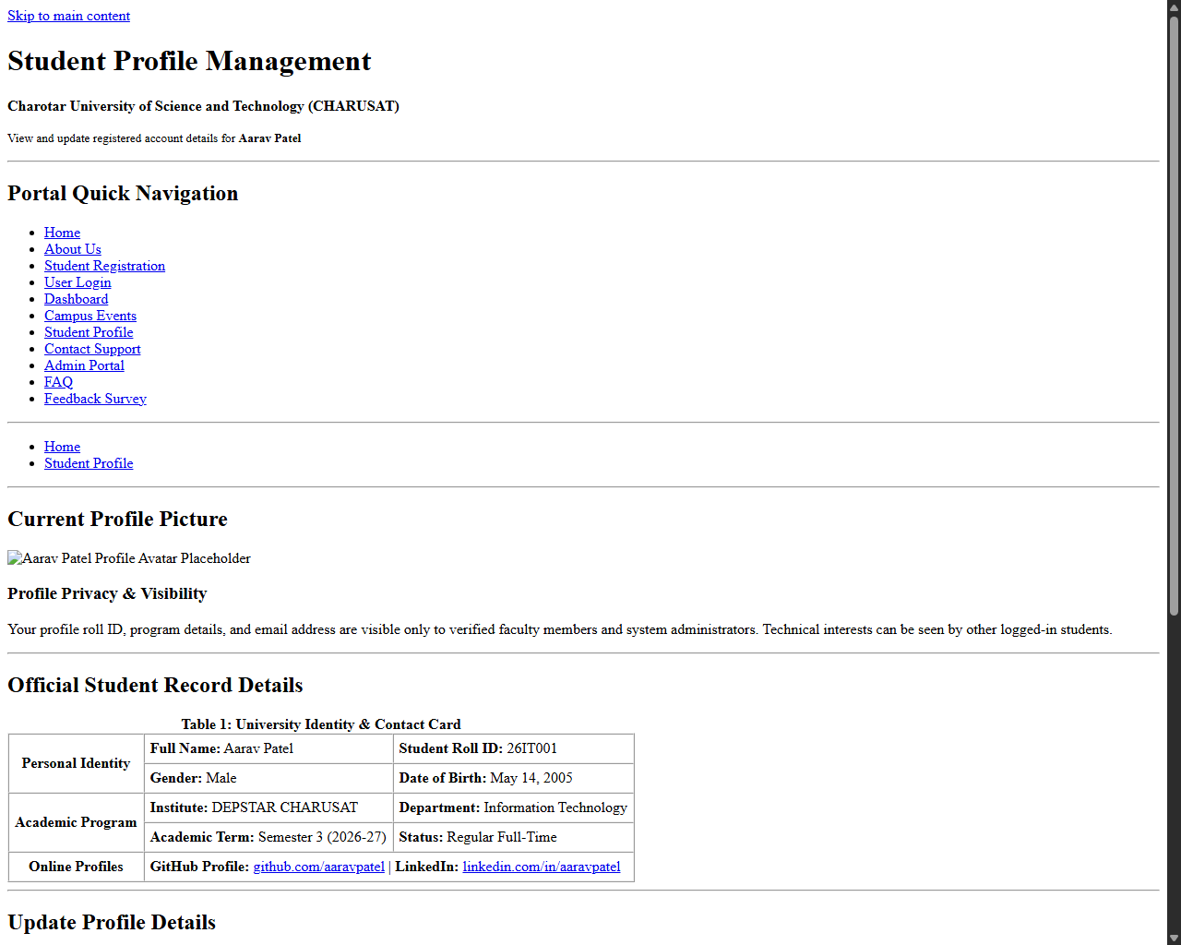
Figure: Browser output screenshot for Student Profile Page

Page: Contact Support Page (contact.html)

Low-Fidelity Wireframe Blueprint
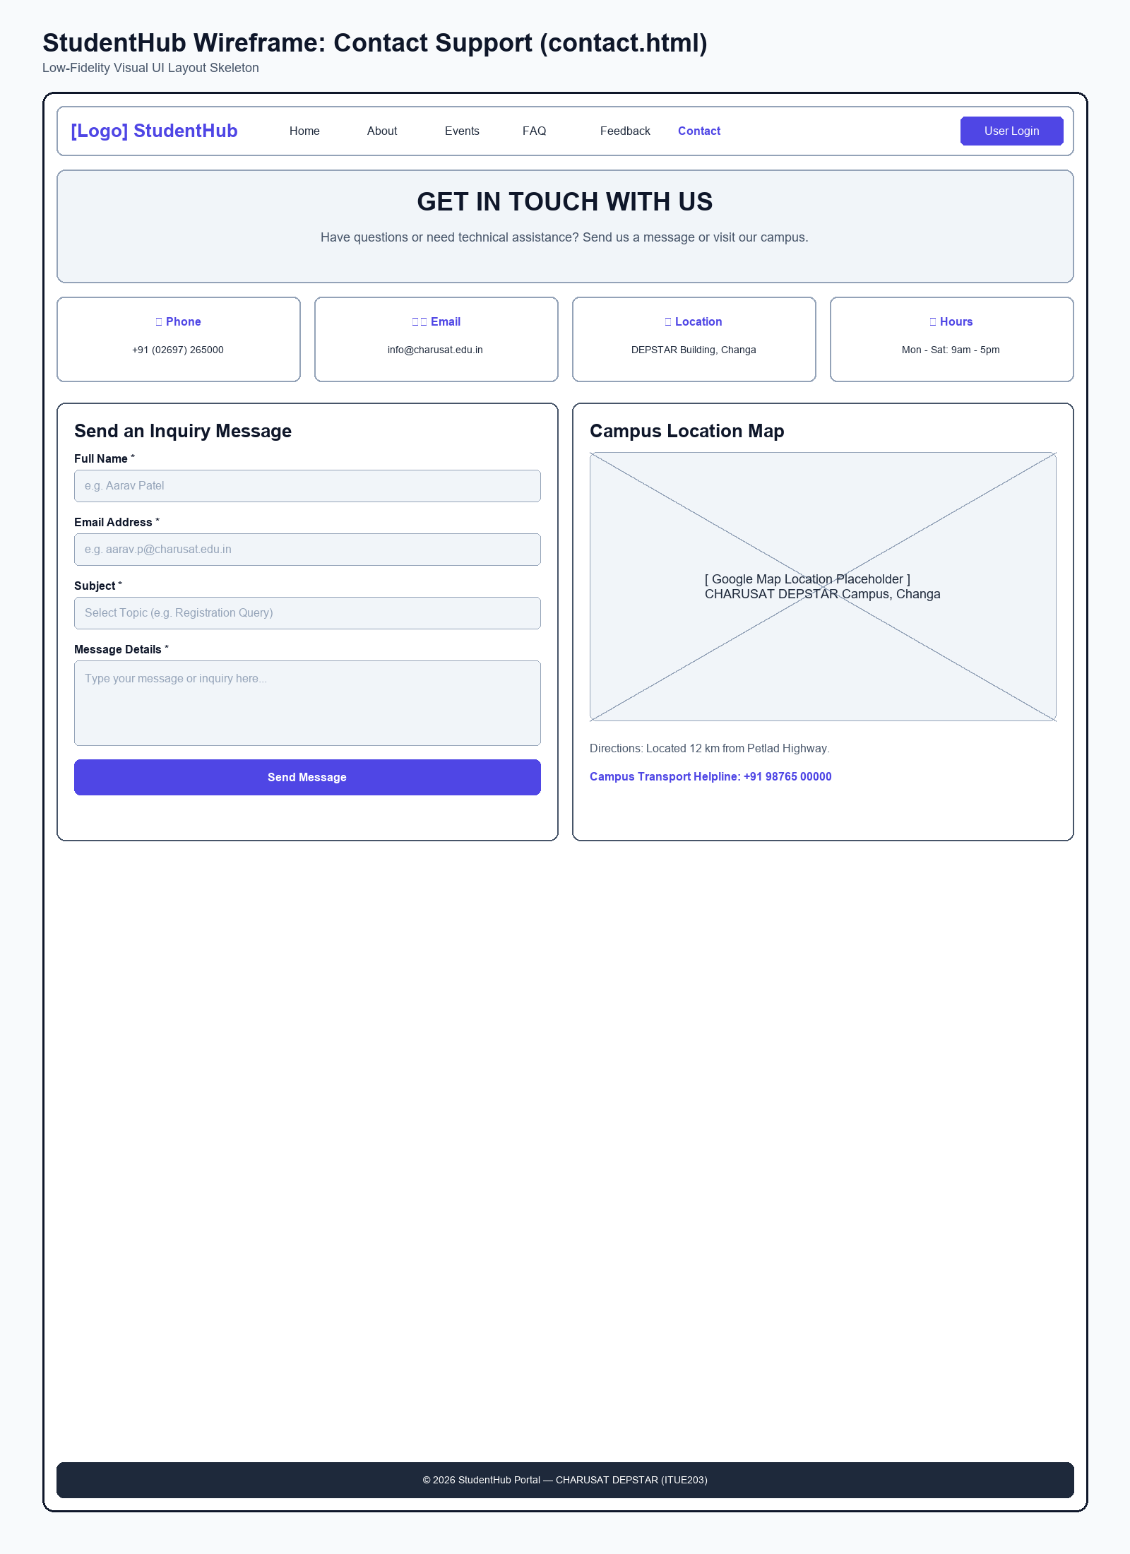
Figure: Wireframe blueprint layout for Contact Support Page

Browser Webpage Output Screenshot
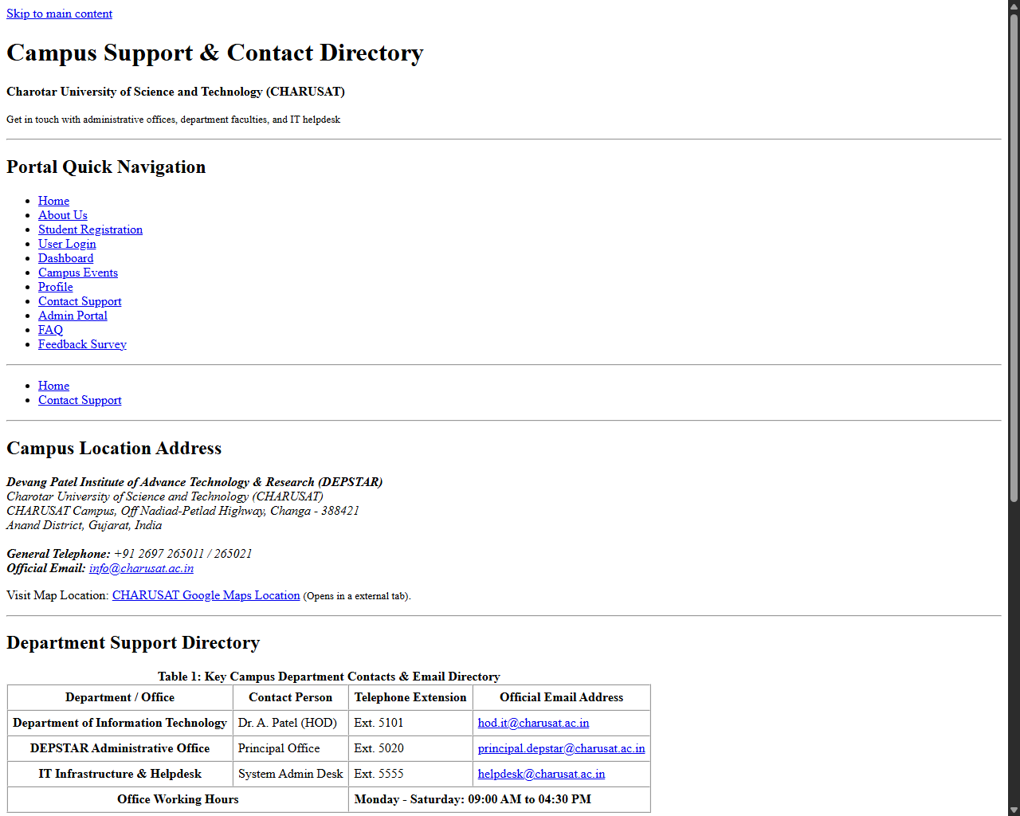
Figure: Browser output screenshot for Contact Support Page

Page: Admin Portal Page (admin.html)

Low-Fidelity Wireframe Blueprint
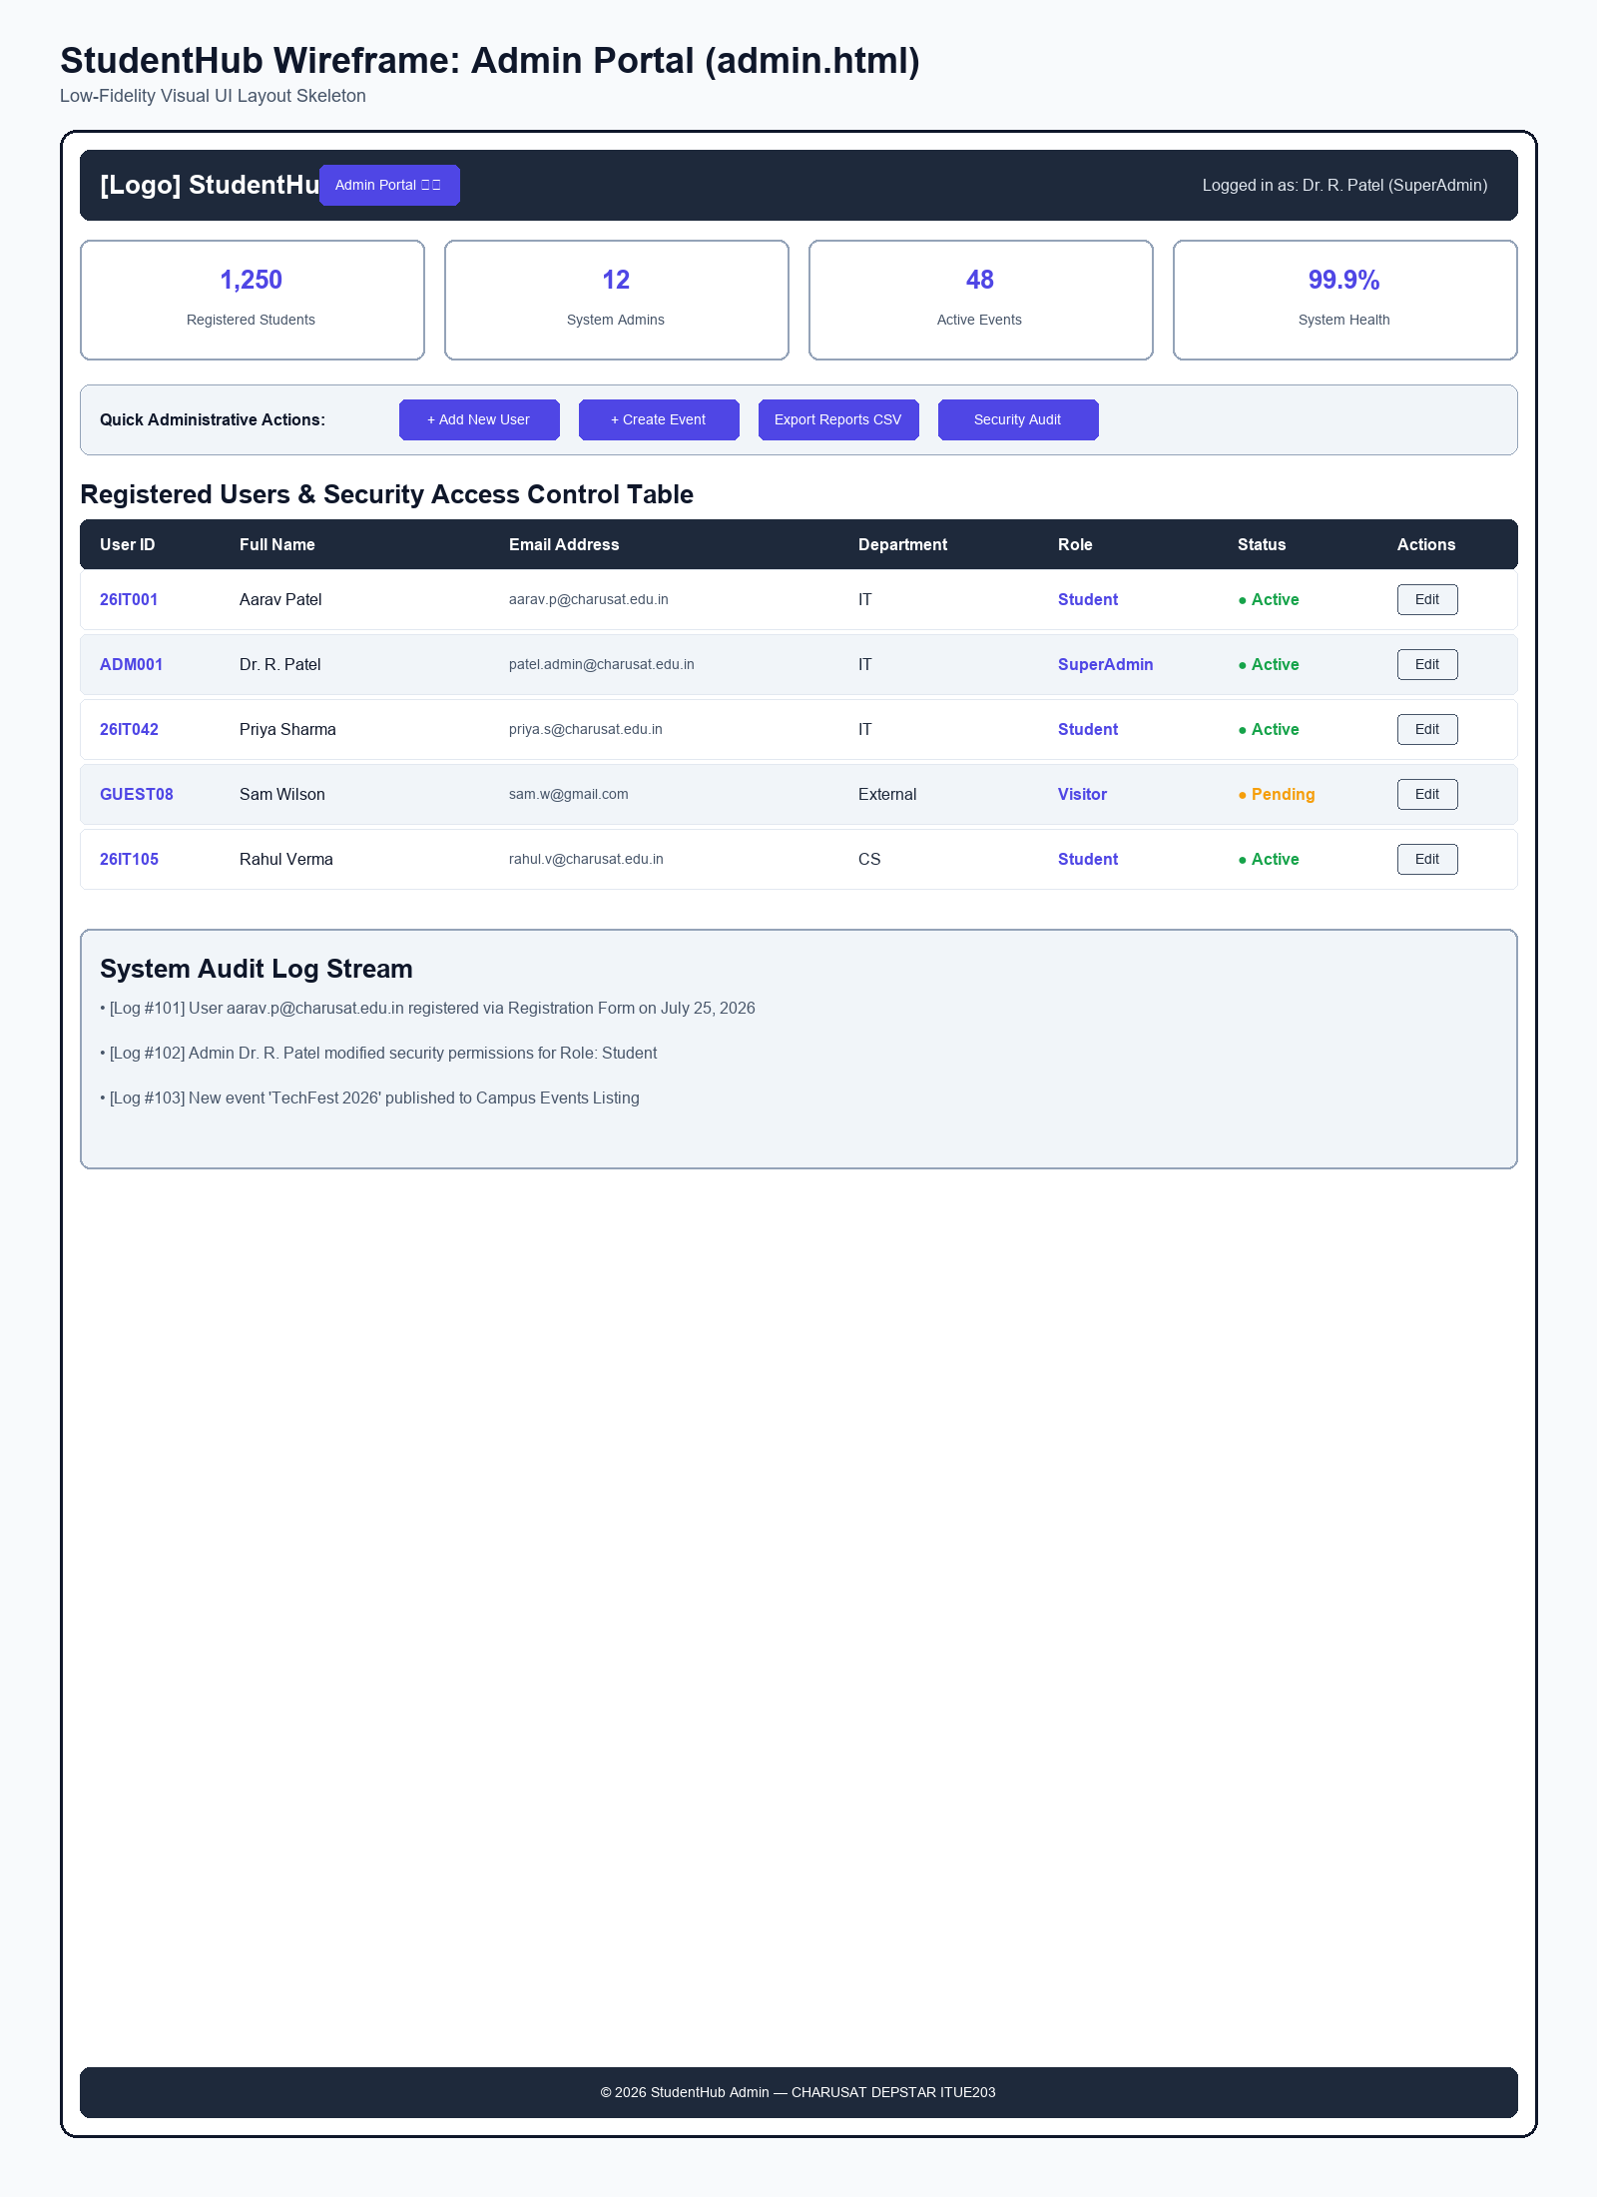
Figure: Wireframe blueprint layout for Admin Portal Page

Browser Webpage Output Screenshot
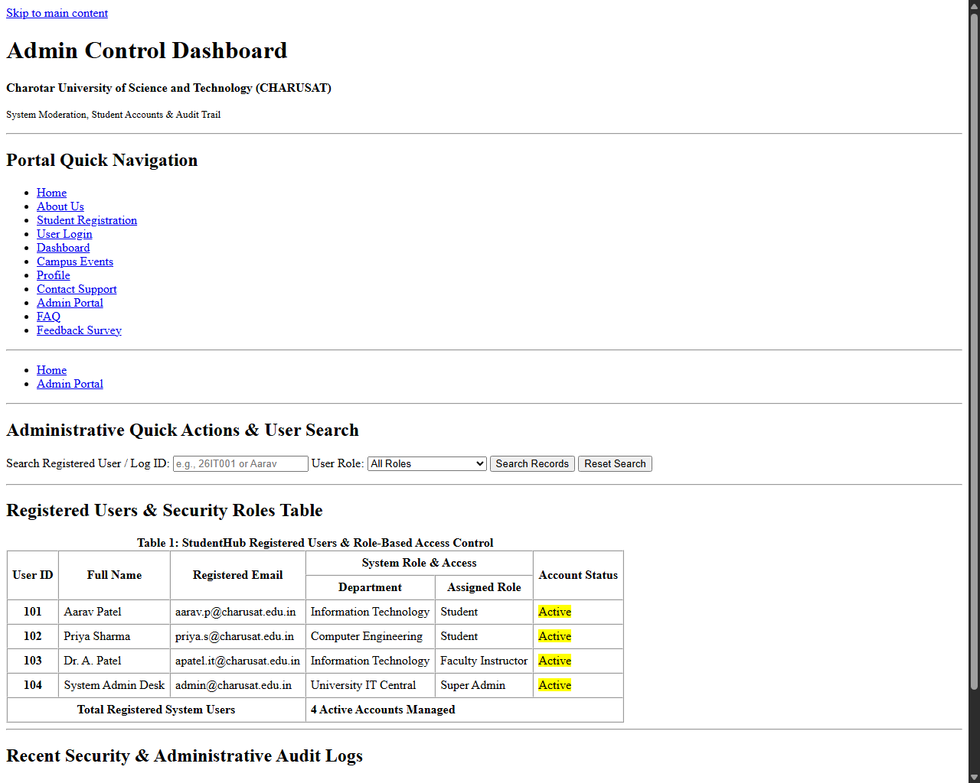
Figure: Browser output screenshot for Admin Portal Page

Page: FAQ Page (faq.html)

Low-Fidelity Wireframe Blueprint
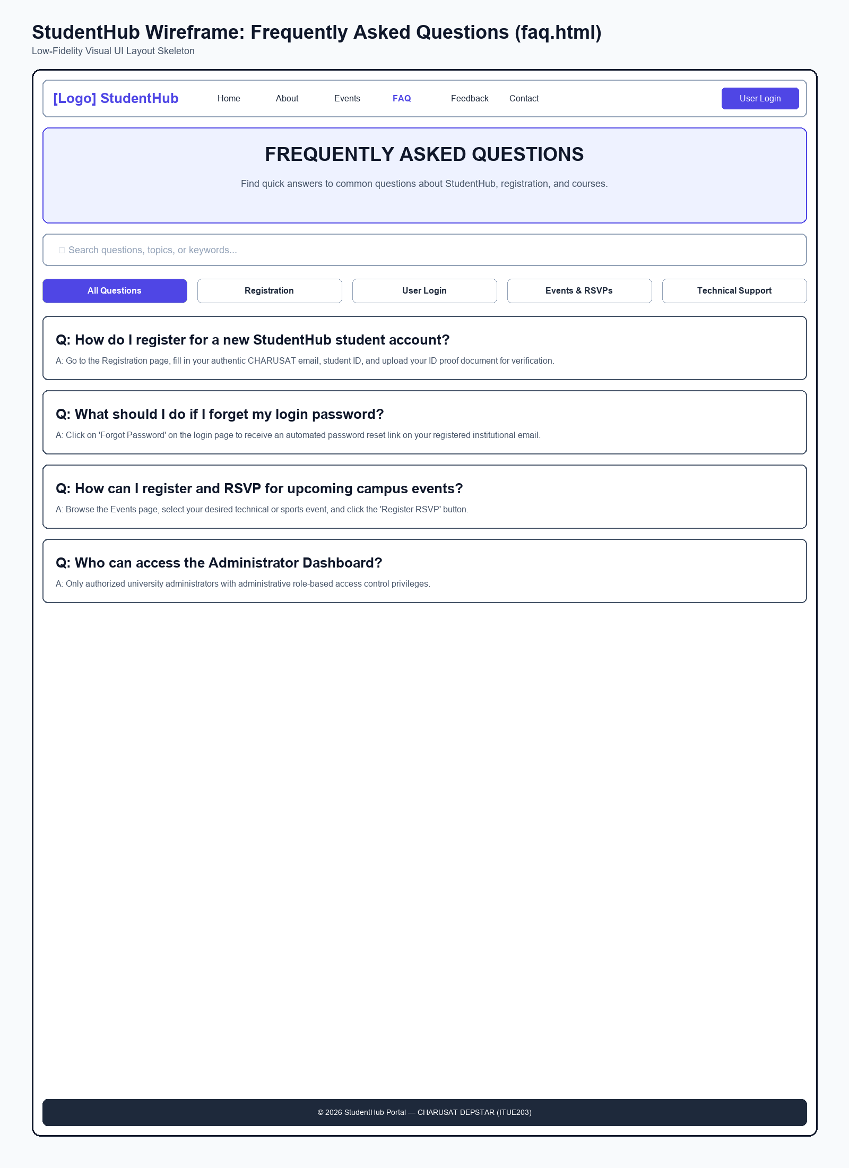
Figure: Wireframe blueprint layout for FAQ Page

Browser Webpage Output Screenshot
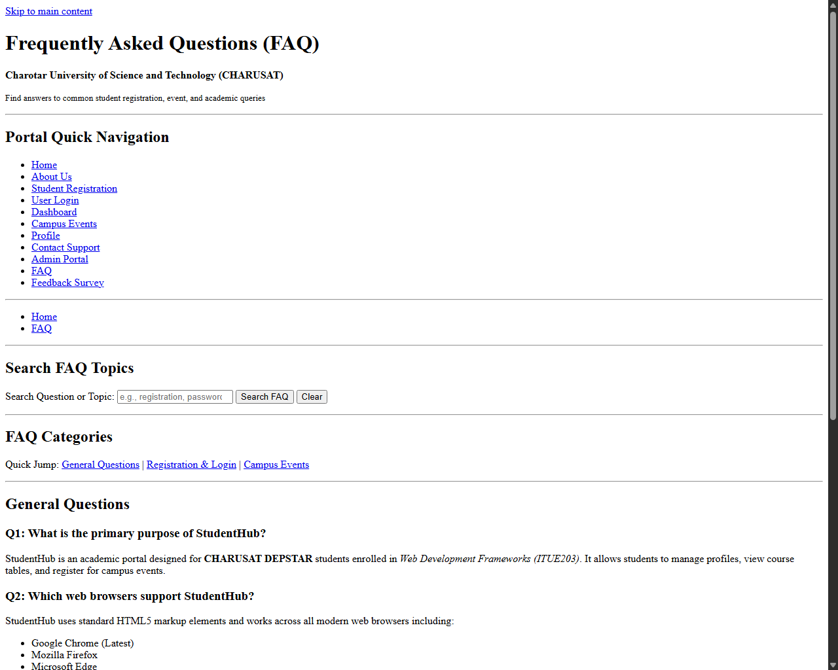
Figure: Browser output screenshot for FAQ Page

Page: Feedback Survey Page (feedback.html)

Low-Fidelity Wireframe Blueprint
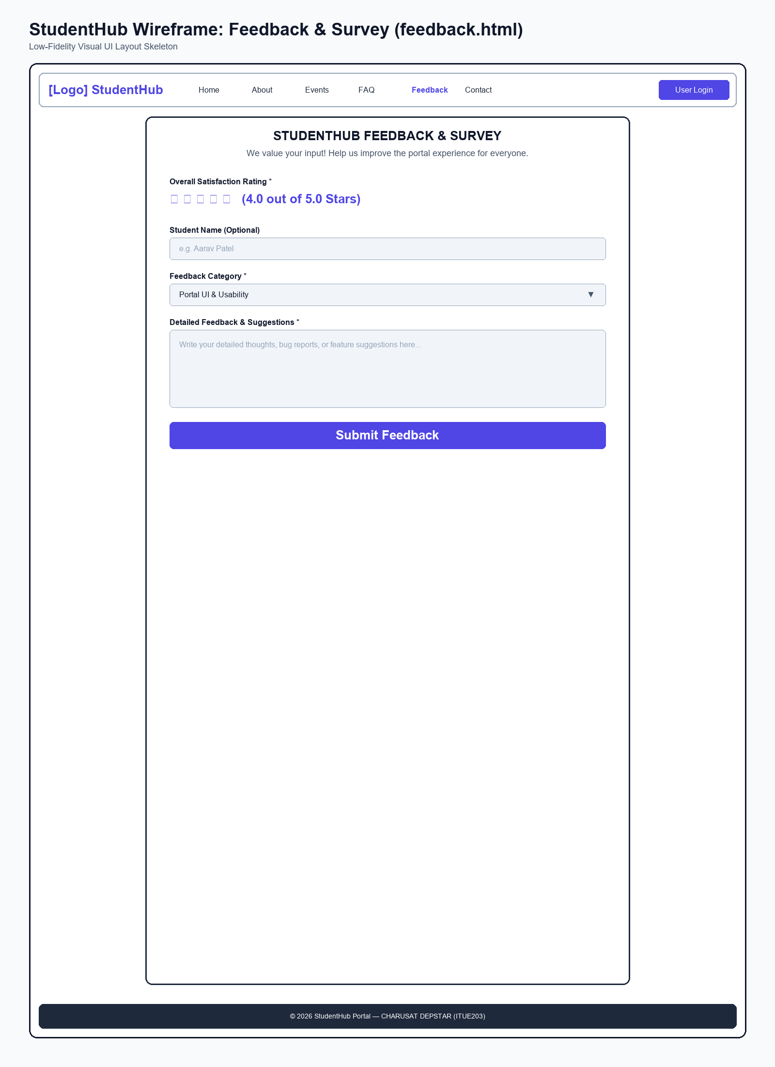
Figure: Wireframe blueprint layout for Feedback Survey Page

Browser Webpage Output Screenshot
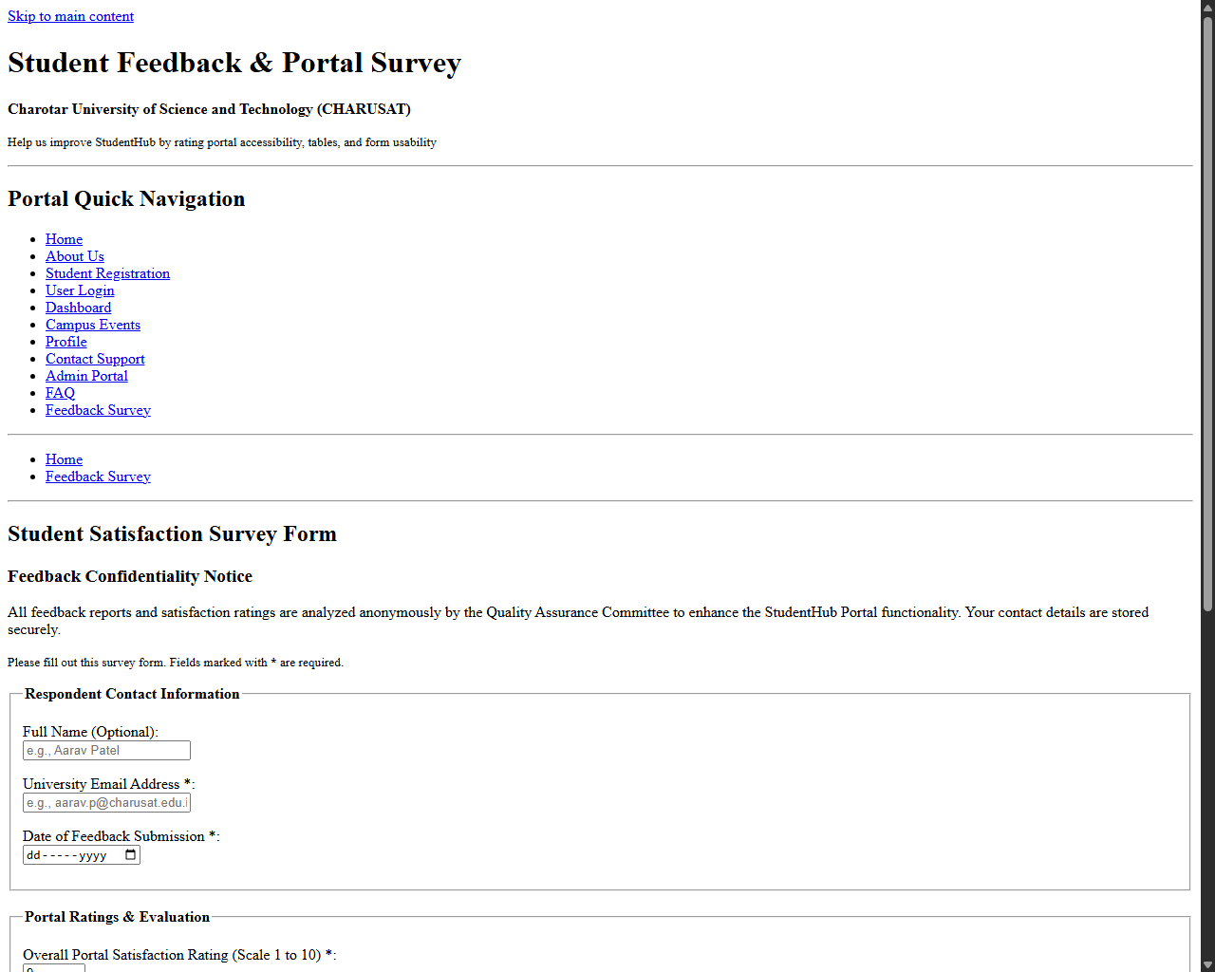
Figure: Browser output screenshot for Feedback Survey Page

